控制面板——防火墙——高级——连接安全规则

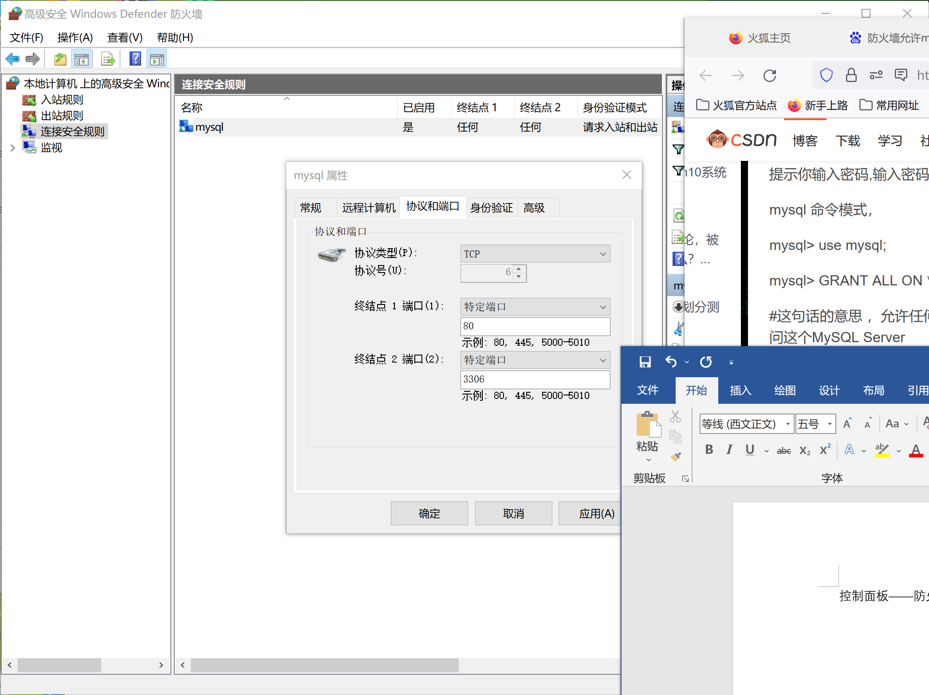

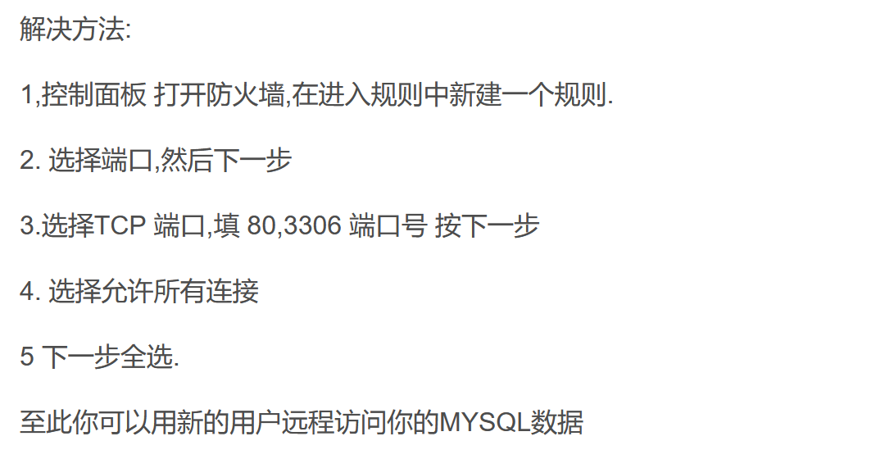

<https://blog.csdn.net/weixin_30499557/article/details/113240277?ops_request_misc=&request_id=&biz_id=102&utm_term=%E9%98%B2%E7%81%AB%E5%A2%99%E5%85%81%E8%AE%B8mysql&utm_medium=distribute.pc_search_result.none-task-blog-2~all~sobaiduweb~default-1-113240277.nonecase&spm=1018.2226.3001.4187>